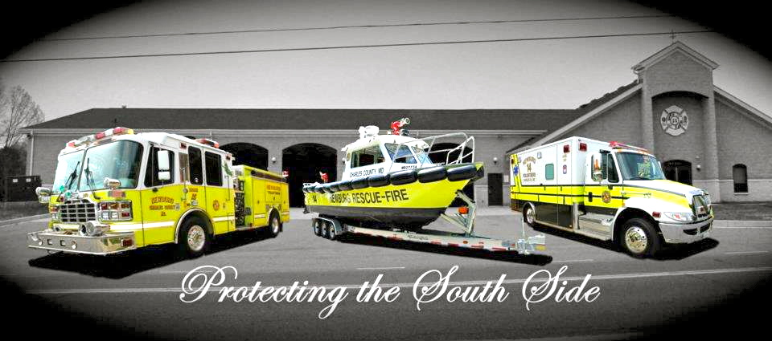

**VENDOR/CRAFT FAIR**

**DECEMBER 8, 2018**

**NEWBURG VOLUNTEER RESCUE SQUAD/FIRE DEPARTMENT**

**8:00 – 2:00**